Grassroots Session # 11
Age Group- U5-U8
10min
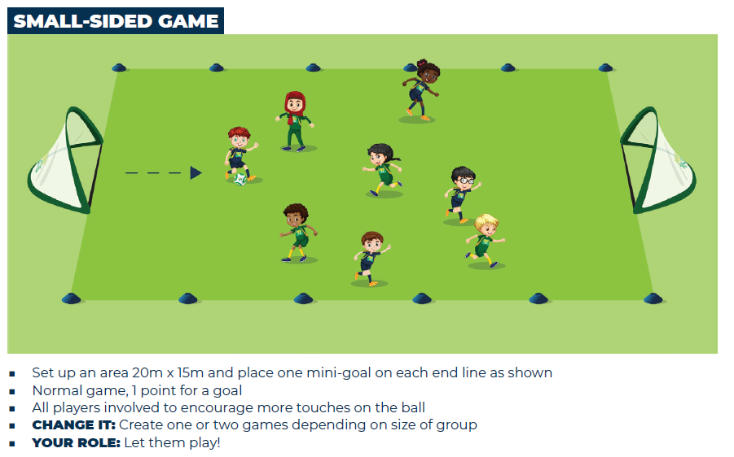

Me and my Shadow
15min
- Players get into pairs, one as a leader the other as a follower.
- The leader is to change direction, touch ground with hands or jump and the follower must copy every move.
- Change the follower to leader and leader to follower
- Change partners
Progression 1
- Follower has a ball and must follower the leader around the field.
- Change roles.
Progression 2
- Both follower and leader have balls.

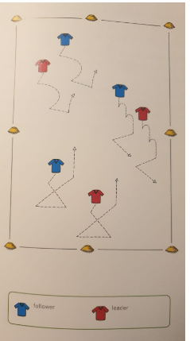

Small Sided Games
10min
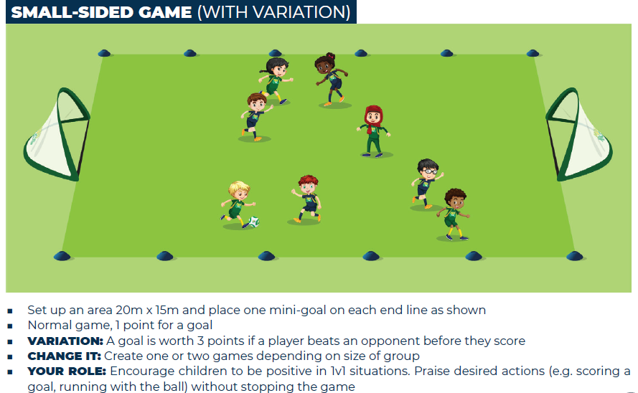

Fun Running with Ball Game
15min

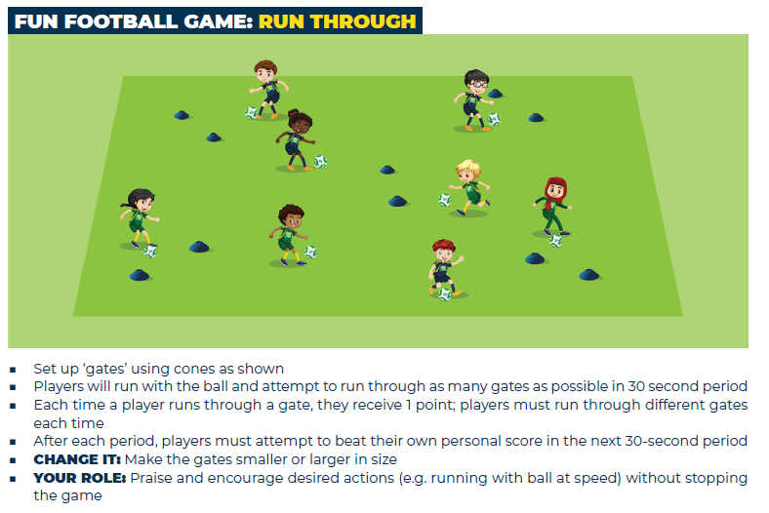

Small Sided Games
10min
